Test Approach for Buggy Cars Rating

# Application to be Tested <https://buggy.justtestit.org> Scope and Objective

The objective of this test project is to find as many bugs as possible in the application before it is released to ensure we deliver a quality product.

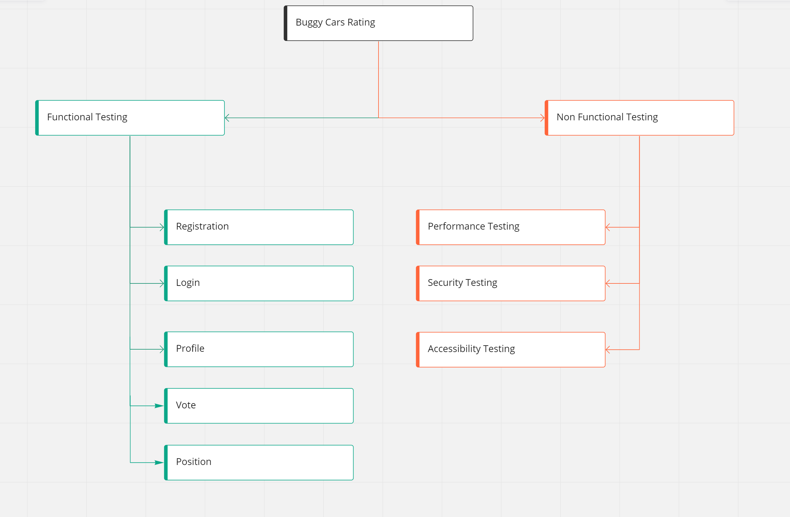

|  |  |
| --- | --- |
| **In Scope**   * Function Testing * Registration * Login * Profile * Vote * Position (Ranking) | **Out of Scope**   * Performance Testing * Security Testing * Accessibility Testing |

## Tools

Automation tools used:

* Webdriverio
* Node JS